Robert Weischedel

CS 5780

4/5/17

Lab 7 Post Lab

1. Derivation of the 1st-order transfer function without friction.

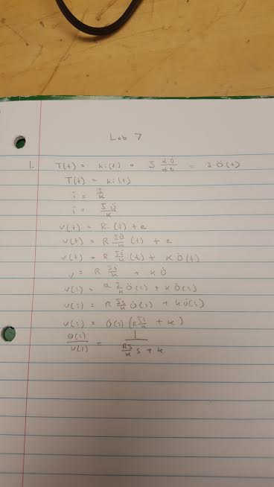

1. Discussion on the effects of simulating the transfer function while changing the different constants.
   * Just a brief mention of the effect that changing each parameter has on the simulation is sufficient. No need for details, or many trials.

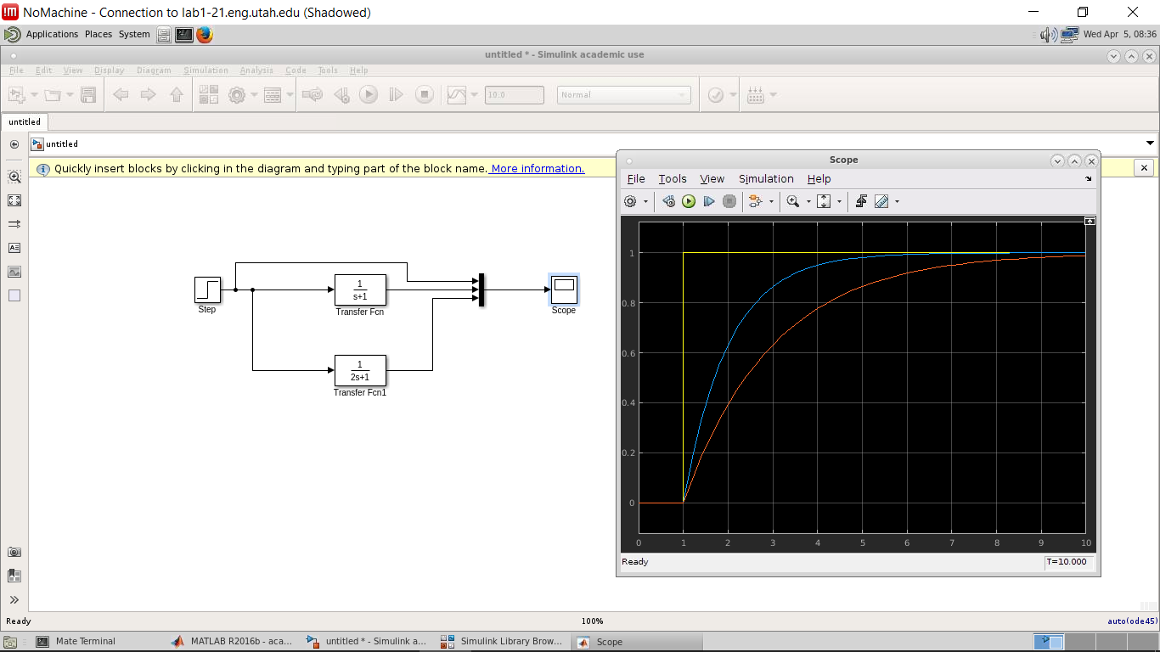

As you double the about of the s value or as you have a heavier load, you can see that the amount of time it takes to get the motor up to the desired speed takes longer.

1. Derivation of the 1st-order transfer function with friction.

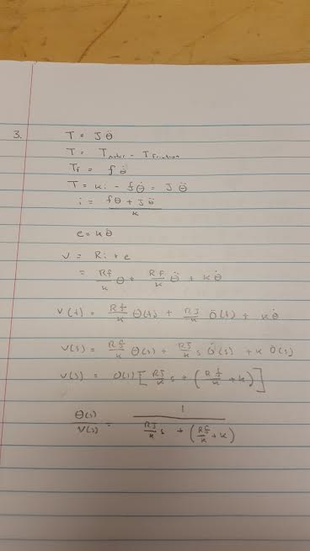

1. Rearranged transfer function for use in Simulink.

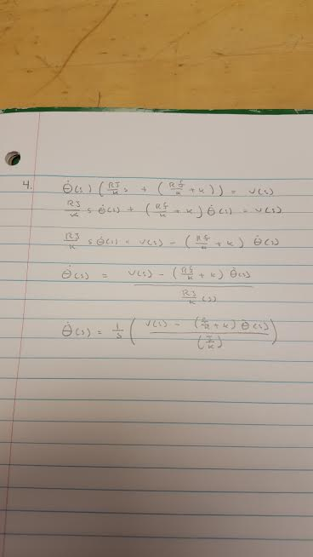

1. Screenshot of your Simulink subsystem model.

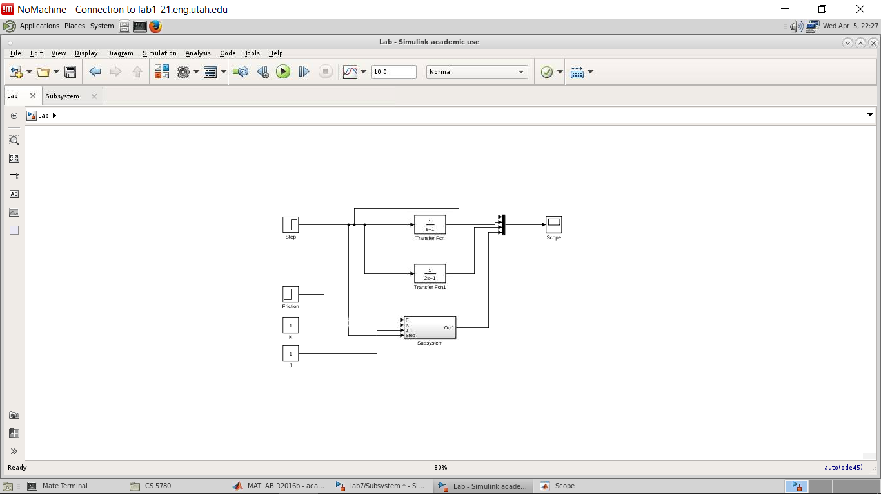

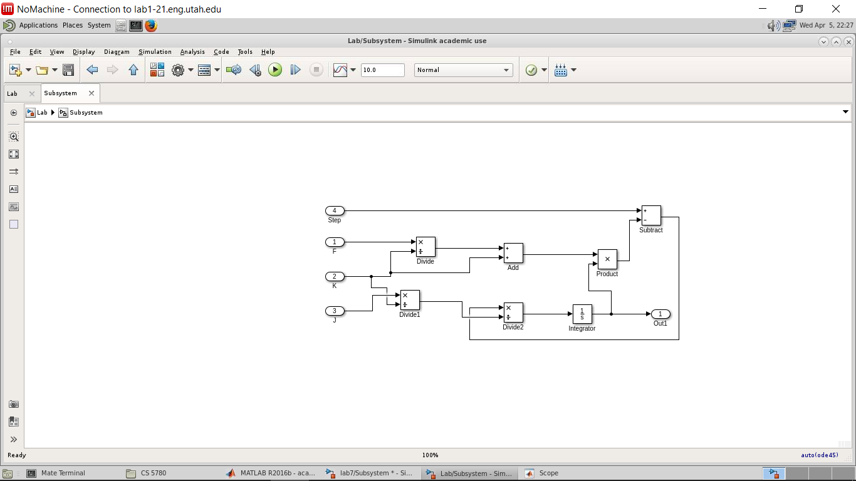

1. Labeled screenshot of one simulation of the subsystem model.

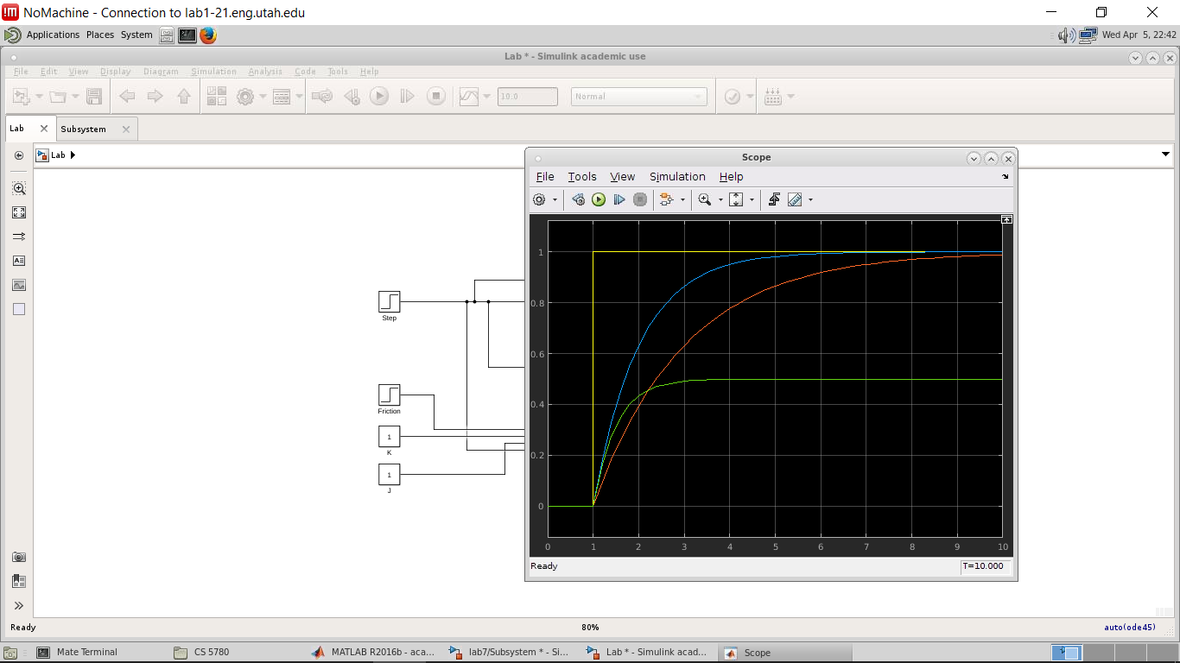

1. What happens when the friction parameter changes mid-simulation?

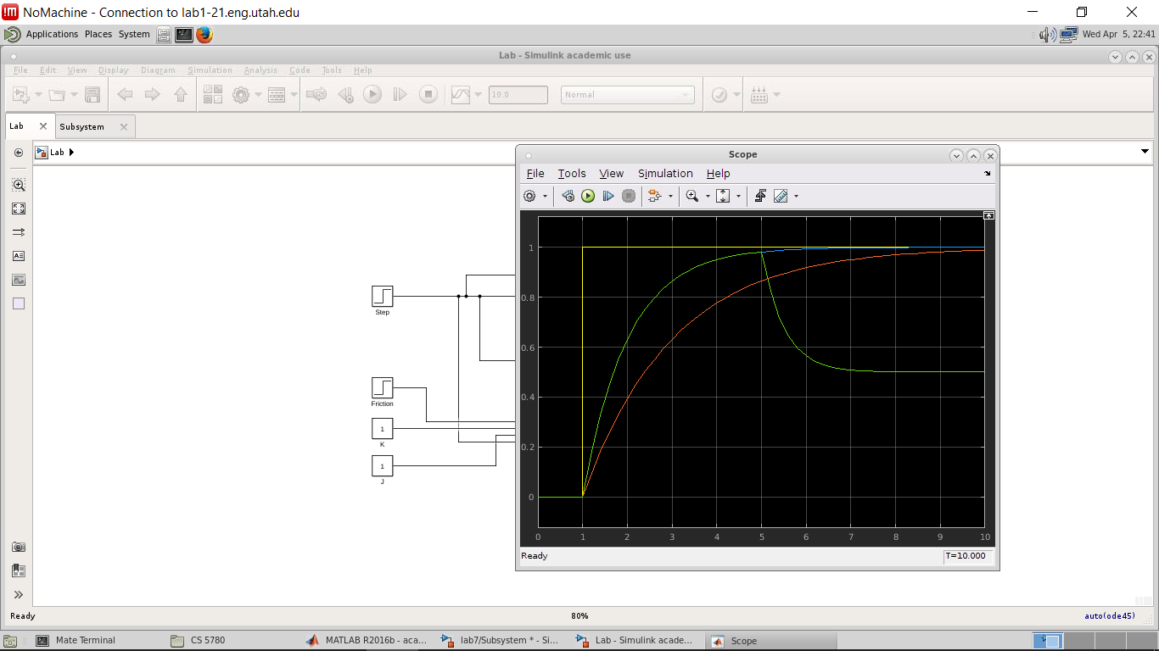

As seen by the image above as we add friction the overall speed of the motor drops and it does not recover and return to its original speed.

1. What can cause friction to dynamically change in a physical system?

One example that comes to mind is that while the motor is traveling over a carpeted floor and then transitions to a tile floor causing the friction coefficient to drop. Or if an increased load is placed on the motor during its run time would also cause the friction coefficient to increase. Basically there are numerous environmental factors that can affect this.

1. Screenshot and mention on the performance of your proportional control system.

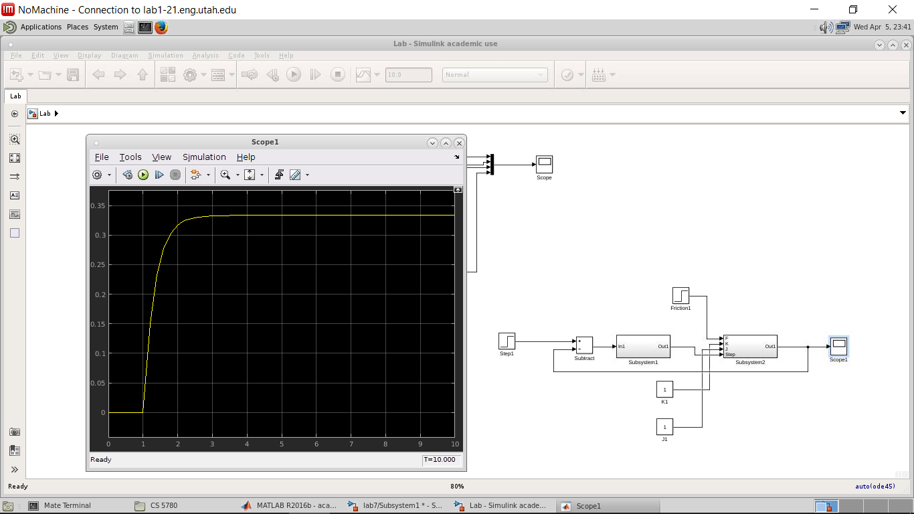

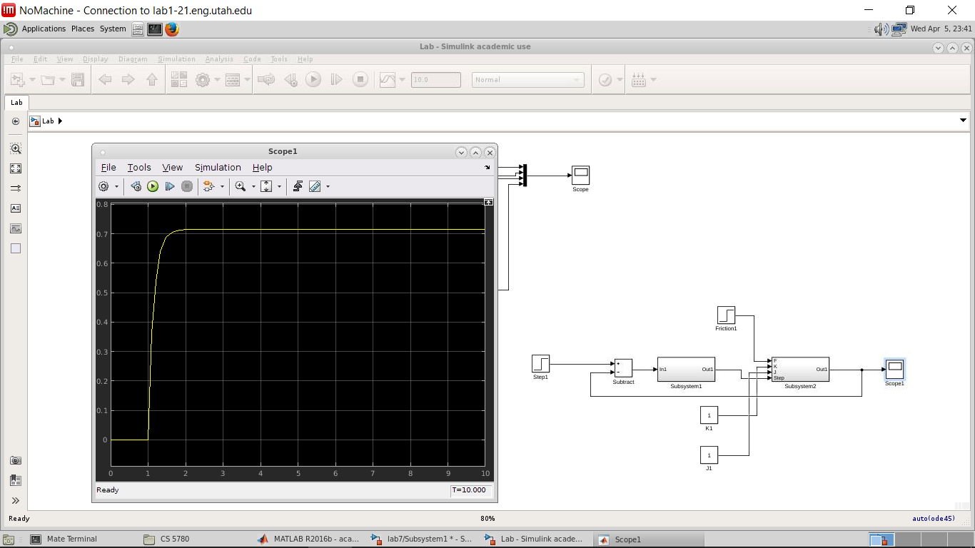

The first screenshot shows the Kp value at 5 and the second screen shot shows the Kp at 1. It appears as the lesser the gain value is the quicker the motor reaches its desired speed. It is also interesting to see how even the P in the PID is able to drastically help the motor maintain and reach a speed close to the desired speed despite the cost of friction.

1. Screenshot and mention on the performance of your integral control system.

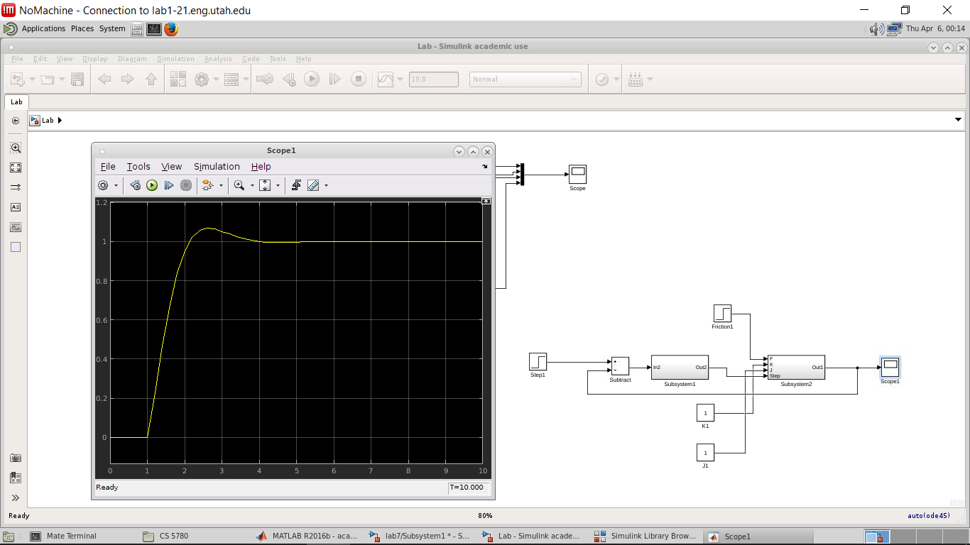

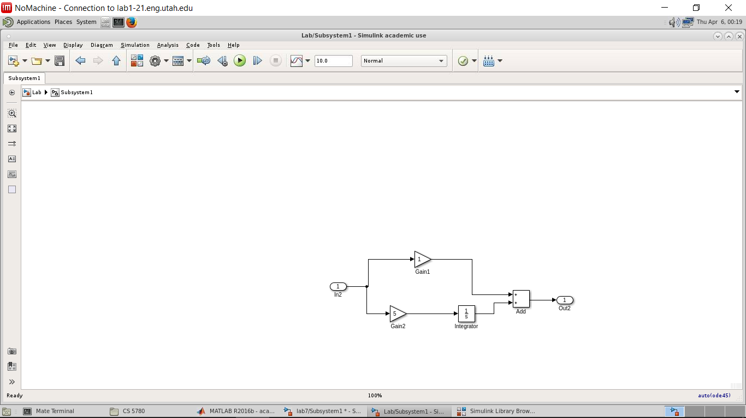

It was interesting to see with the adding of the integral portion we were actually able to reach the desired speed of 1. From what I learned in this small experiment was when we add the integral portion to PI, we see exceptional growth until we even surpass the desired speed value, until we even back out and reach the desired speed. Which makes sense because since the integral is a summation of values those values can potentially overshoot our target at times, but the entire summation levels out the value.